11.32: a) Solving Eq. (11.14) for the volume change,
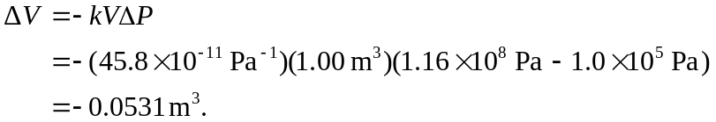

b) The mass of this amount of water not changed, but its volume has decreased to 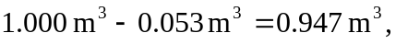 and the density is now 